**Project Design Phase-II**

**Technology Architecture**

|  |  |
| --- | --- |
| Date | 10 October2022 |
| Team ID | PNT2022TMID51379 |
| Project Name | Plasma Donor Application |
| Maximum Marks | 4 Marks |

**Technology Architecture:**

Technical Architecture (TA) is **a form of IT architecture that is used to design computer systems**. It involves the development of a technical blueprint with regard to the arrangement, interaction, and interdependence of all elements so that system-relevant requirements are met.

* The user interacts with the application.
* Registers by giving the details as a donor.
* The database will have all the details and if a user posts a request then the concerned blood group donors will get notified about it.

**Technology Architecture Diagram:**

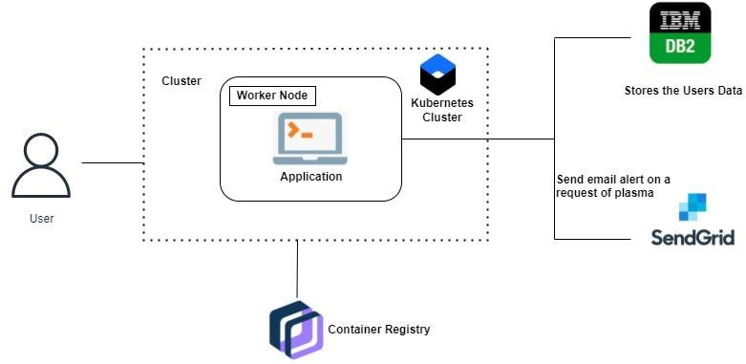

**PLASMA DONOR APPLICATION**